# Laboratory 7

Title of the Laboratory Exercise: To integrate database using JDBC to web application

1. Introduction and Purpose of Experiment

Students will learn to implement JDBC component for all the functional requirements identified.

1. Aim and Objectives

Aim

1. Experimental Procedure
2. Calculations/Computations/Algorithms

UserDao.java

*package* *webarch.dao*;

*import* *java.math.BigInteger*;

*import* *java.security.MessageDigest*;

*import* *java.security.NoSuchAlgorithmException*;

*import* *java.sql.Connection*;

*import* *java.sql.PreparedStatement*;

*import* *java.sql.ResultSet*;

*import* *java.sql.SQLException*;

*import* *java.sql.Statement*;

*import* *webarch.db.DBConnection*;

*public* *class* UserDao {

*public* *static* *String* getMd5(*String* input) {

*try* {

*// Static getInstance method is called with hashing MD5*

*MessageDigest* md = MessageDigest.getInstance("MD5");

*// digest() method is called to calculate message digest*

*//  of an input digest() return array of byte*

*byte*[] messageDigest = md.digest(input.getBytes());

*// Convert byte array into signum representation*

*BigInteger* no = *new* BigInteger(1, messageDigest);

*// Convert message digest into hex value*

*String* hashtext = no.toString(16);

*while* (hashtext.length() < 32) {

                hashtext = "0" + hashtext;

            }

*return* hashtext;

        }

*// For specifying wrong message digest algorithms*

*catch* (*NoSuchAlgorithmException* e) {

*throw* *new* RuntimeException(e);

        }

    }

*public* *static* *boolean* registerUser(*String* username, *String* password, *String* fullname, *String* usnno, *String* dept, *String* course ) {

*Connection* conn = DBConnection.getDbConnection();

*try* {

*PreparedStatement* stmt = conn.prepareStatement("INSERT INTO `STUDENT_LOGIN` (`user_name`, `hashed_password`) VALUES(?, ?)", Statement.RETURN_GENERATED_KEYS);

            stmt.setString(1, username);

            stmt.setString(2, getMd5(password));

            stmt.executeUpdate();

*ResultSet* rs = stmt.getGeneratedKeys();

*if* (rs.next()) {

*Integer* id = rs.getInt(1);

*PreparedStatement* stmt2 = conn.prepareStatement("INSERT INTO STUDENT( id, reg_no, name, department, course, contact_no ) VALUES (?, ?, ?, ?, ?, ?)");

                stmt2.setInt(1, id);

                stmt2.setString(2, usnno);

                stmt2.setString(3, fullname);

                stmt2.setString(4, dept);

                stmt2.setString(5, course);

                stmt2.setString(6, "9999999999"); *// hardcoded value for now*

*int* count = stmt2.executeUpdate();

*if* (count > 0)

*return* *true*;

*else*

*return* *false*;

            }

            rs.close();

        } *catch* (*SQLException* e) {

            e.printStackTrace();

*return* *false*;

        }

*return* *false*;

    }

}

DBConnection.java

*package* *webarch.db*;

*import* *java.sql.Connection*;

*import* *java.sql.DriverManager*;

*import* *java.sql.SQLException*;

*public* *class* DBConnection {

*private* *static* *Connection* conn;

*public* *static* *Connection* getDbConnection() {

*if* (conn == *null*) {

*try* {

                Class.forName("com.mysql.jdbc.Driver");

                conn = DriverManager.getConnection("jdbc:mysql://localhost:3306/webarch", "root", "");

            } *catch* (*SQLException* e) {

                e.printStackTrace();

            } *catch* (*ClassNotFoundException* e) {

                e.printStackTrace();

            }

        }

*return* conn;

    }

}

1. Presentation of Results

Registration of User

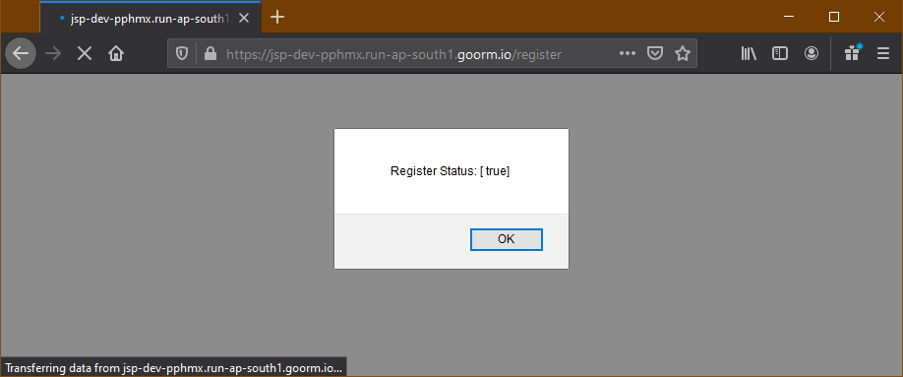

User successfully added in the database

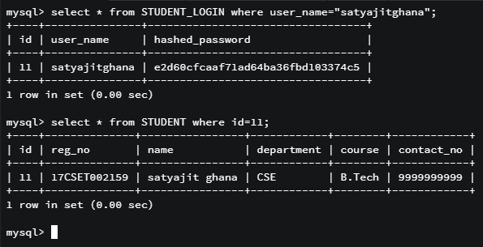

1. Analysis and Discussions
2. Conclusions
3. Comments

a. Limitations of Experiments

b. Limitations of Results

c. Learning happened

d. Recommendations

|  |  |  |
| --- | --- | --- |
| **Component** | **Max Marks** | **Marks Obtained** |
| **Viva** | **6** |  |
| **Results** | **7** |  |
| **Documentation** | **7** |  |
| **Total** | **20** |  |